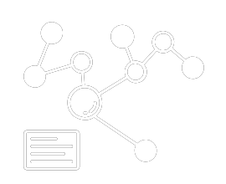

***The***

***perfect***

***website builder***

***for you***.

2013 Airport N Rd, NAIROBI

EMBAKASI, Sagiki Enterprise

Phone: +2547 9890 8146 cand.it.webdesigner@gmail.com

WWW.CANDIT.COM

WEB DESIGNER

WEB ENGINEER

With CAND.IT

Build more than just a

Website. From selling online, starting a blog,

Organising events to promoting your business and building

Your community. Creating a website that grows with you.

A website (also written as a web site) is a collection of web pages and related content that is identified by a common domain name and published on at least one web server. Websites are typically dedicated to a particular topic or purpose, such as news, education, commerce, entertainment or social networking.

CAND.IT – a company, a partner, and an ally that creates, designs and develops astonishing websites for the purpose of your success

• Opes sed nonummy tation verto augue pecus.

• Venio regula ea vel fatua incassum.

• Wisi regula eum consectetuer ut mos tamen enim.

• Feugait regula. Ut amet opes ideo gemino et

• Opes sed nonummy tation verto augue pecus.

**CAND.IT**

YOUR WEBSITE SOLUTION

We design and develop experiences that make lives simple.

At CAND.IT we create, Develop and polish for the success of

Your business and projects with the very best websites just for you.

**WEBSITES WITH INFINITE POSSIBILITIES.**

CANDIT BUILDS FOR YOU WEBSITES WITH NO LIMITS.

Build and scale with confidence, from a powerful website to a successful

business, project, blog and also community solutions.

Make it with candit

**AT CAND.IT WE**

**• WEBSITE DEVELOPMENT.**

**• WEBSITE DESIGNING.**

**• WEBSITE MAINTAINACE.**

**• ONLINE BRANDING.**

**• ADVERTISING SERVICES.**

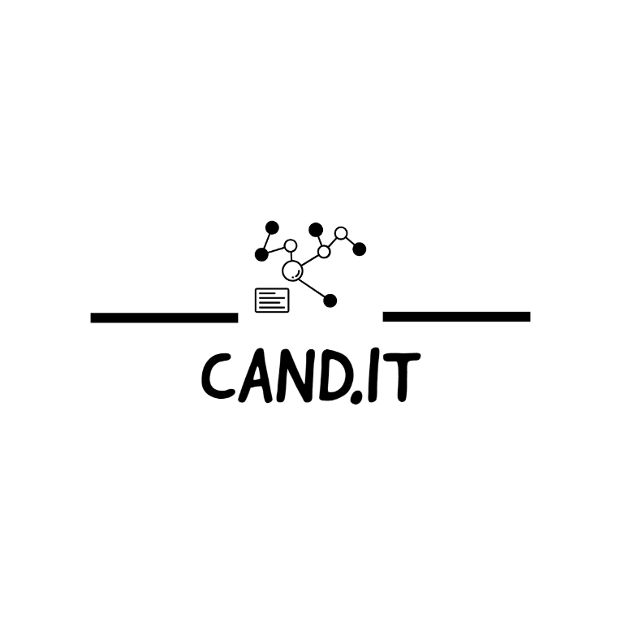

flexible solutions for

your business needs

CUSTOM SOLUTIONS

At Management Systems, a “customized solution” we consist of the tools (one or more) selected to best meet client needs and how these tools are packaged and delivered within and to the client.

WEB SOLUTIONS

We build solutions with great design in mind and we always use the most suitable front end and back end technology for each individual need.

E-BUSINESS SOLUTION

Providing up to date systems and softwares

in addition to re-engineered business processes to develop innovative Web applications that support online business activities. Small Business Collaboration Through Electronic Marketplaces.

WE’VE GOT THE SOLUTION TO YOUR PROBLEM!

Don’t hesitate to reach us, take your project and business to where you need it to goooooo !

Transform your online presence with our captivating website design service. We craft stunning,

User friendly websites that engage your audience. Elevate your brand, boost conversations and

Take the first step towards online success.

Contact us today to bring your vision to life

.**We also offer**

* **Professional crafted websites.**
* **Domain names eg. (.com .co.ke)**
* **Free hosting for a certain time span.**
* **Graphic designs for business.**
* **Flyer Design for business.**
* **Bronchure designs.**
* **Search engine**
* **Company profile.**